Week-08-Sorting Algorithms-Bubble and Selection

Week 08-01-practice session coding

Reg no : 241801304

Name : Ukirtha S

Q1)

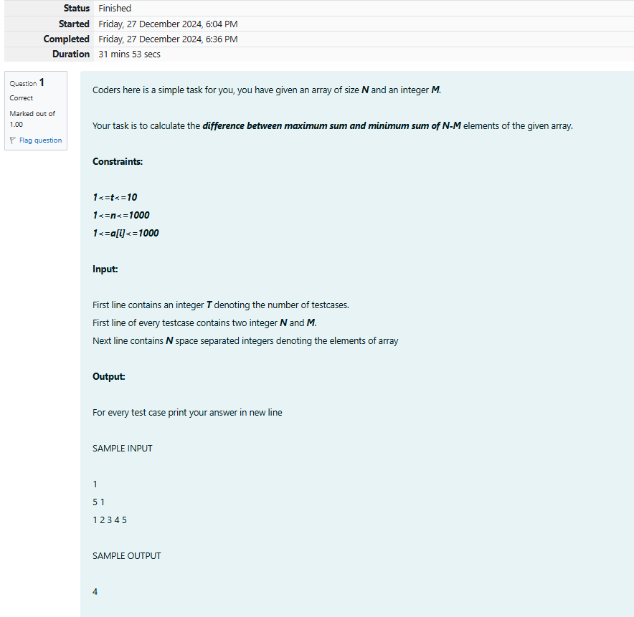

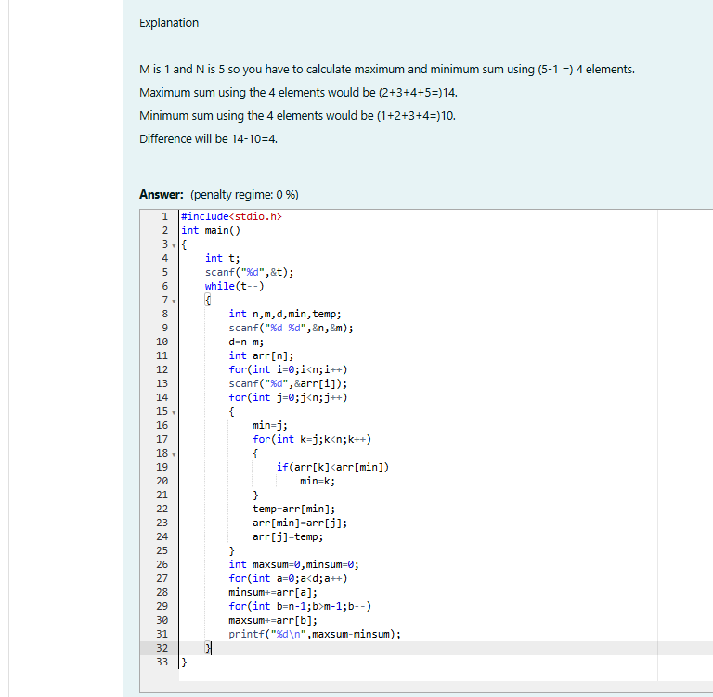

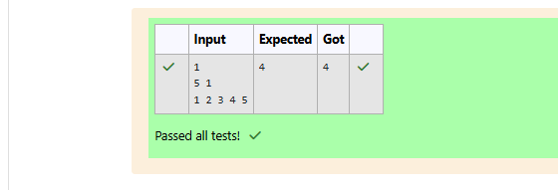

Week 08-01-practice session coding

Reg no : 241801304

Name : Ukirtha S

Q2)

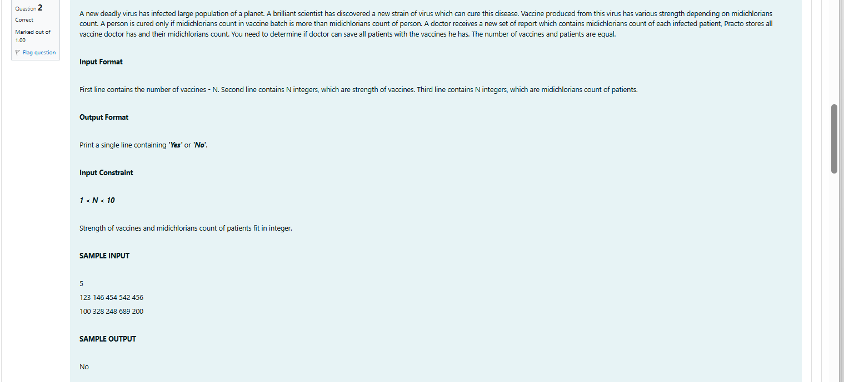

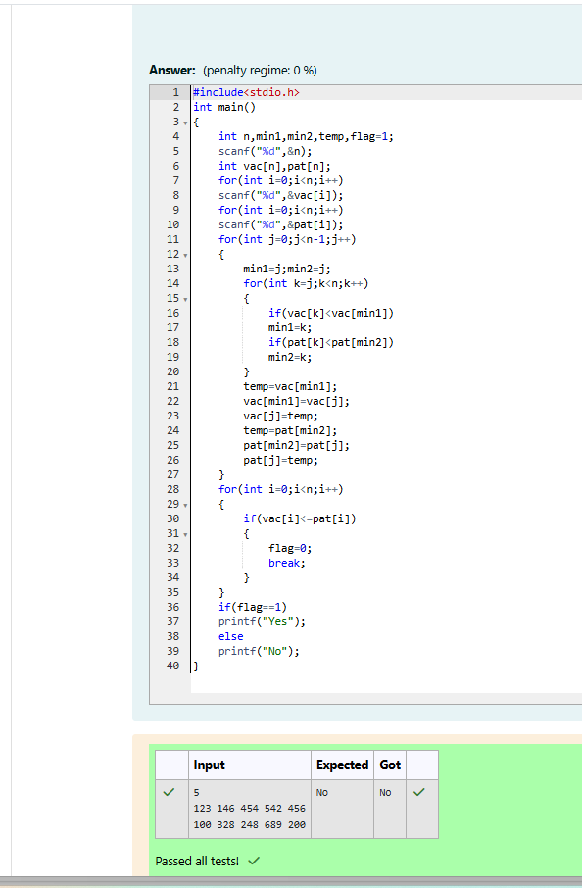

Week 08-01-practice session coding

Reg no : 241801304

Name : Ukirtha S

Q3)

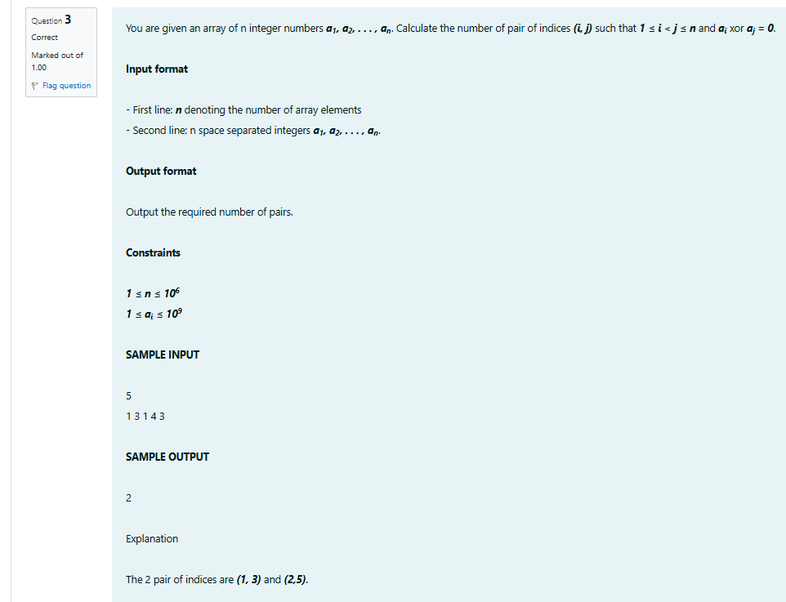

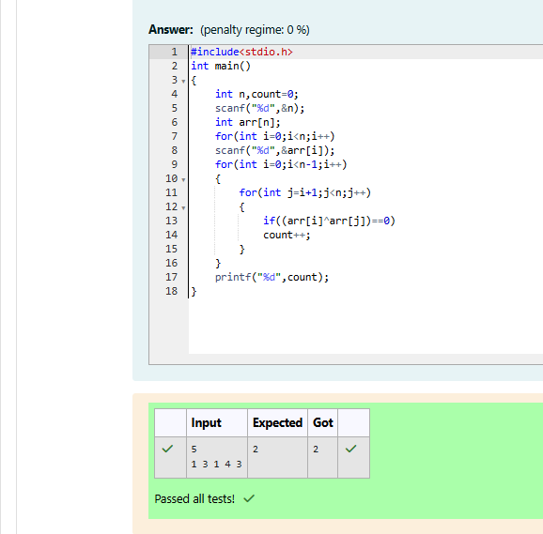

Week 08-01-practice session coding

Reg no : 241801304

Name : Ukirtha S

Q4)



